
Data Visualization techniques
Lab Final report

Name: | Malaika Tariq  Saleha Yasir
Registration No.: | SP23-BDS-025  SP23-BDS-045
Instructor: | Dr. Sheneela Naz
Due Date: | 19/06/2026

Executive Summary
This project is an interactive web-based data visualization dashboard built with D3.js, HTML5, and CSS3 for the Data Visualization Techniques course (DSC327). The dashboard presents insights from a startup ecosystem dataset of 500 companies using 8 carefully designed, interactive visualizations with cross-filtering capabilities — enabling exploratory data analysis and pattern discovery.

Metric | Value
Total Startups Analyzed | 500
Total Funding (M USD) | $76,328.4
Average Valuation (M USD) | $1,371.8
Profitable Startups | 216 (43.2%)
Industries Covered | 8 (EdTech, FinTech, AI, IoT, Gaming, E-Commerce, Cybersecurity, HealthTech)
Visualizations Implemented | 8 interactive charts
Deployment | GitHub Pages (Production Ready)

1.1 Dashboard Overview
The dashboard opens with four key performance indicators that immediately convey the scale of the startup ecosystem dataset.

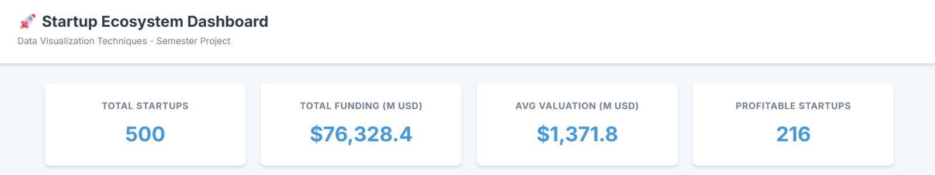
Figure 1: KPI Summary Cards — Total Startups, Funding, Valuation, and Profitable Startups

Total Startups  500 | Total Funding  $76,328.4M | Avg Valuation  $1,371.8M | Profitable  216

1. Project Overview

1.1 Objective
To create a fully functional, production-quality web application that visualizes complex startup data using best practices in data visualization design, UI/UX, interactivity and responsiveness, and modular code organization.

1.2 Technology Stack
Technology | Purpose
HTML5 | Document structure and semantic markup
CSS3 | Styling, responsive grid layout, animations
JavaScript (ES6+) | Core logic, data processing, event handling
D3.js v7 | Data-driven visualizations and interactions
Git & GitHub | Version control and source code management
GitHub Pages | Free static site hosting and deployment

1.3 Dataset Summary
- Source: Startup ecosystem data (startup_data.csv)
- Records: 500 startups across 8 industry sectors
- Key Variables: Funding, Valuation, Revenue, Employees, Industry, Region, Year Founded, Exit Status, Profitability

2. Dataset Analysis

2.1 Variable Descriptions
Variable | Type | Description | Example
Startup Name | String | Unique identifier | Startup_1
Industry | Categorical | Business sector | IoT, EdTech, Gaming
Funding Rounds | Numerical | Number of funding rounds received | 1 – 5
Funding Amount (M USD) | Numerical | Total capital raised | 10.75 – 249.28
Valuation (M USD) | Numerical | Company market value | 101.9 – 3310.83
Revenue (M USD) | Numerical | Annual revenue | 47.08 – 84.21
Employees | Numerical | Workforce size | 1,000 – 5,000+
Market Share (%) | Numerical | Percentage of market controlled | 2.5 – 8.1
Year Founded | Temporal | Year of establishment | 1990 – 2023
Region | Categorical | Geographic headquarters location | Europe, Asia, S. America
Exit Status | Categorical | Company outcome status | Private, Acquired
Profitable | Boolean | Profitability flag | 0 (No) or 1 (Yes)

2.2 Key Insights Discovered
- Funding-Valuation Correlation: Higher funding generally correlates with higher valuations, but notable outliers exist — startups with modest funding but disproportionately high valuations.
- Industry Dominance: EdTech and FinTech lead with the highest startup counts, suggesting these are the most active sectors.
- Geographic Distribution: The dataset shows spread across multiple global regions including South America, Europe, and Asia.
- Profitability Paradox: Not all well-funded startups are profitable — many prioritize growth over immediate returns (only 43.2% are profitable).
- Temporal Trends: Startup founding peaked around 2021, with a sharp drop-off in 2022-2023, possibly due to market conditions.
- Exit Patterns: Most startups remain private; only a small fraction have been acquired, indicating a relatively young ecosystem.

3. Data Preprocessing

3.1 Cleaning Strategy
CSV data imported all values as strings. Solution: Implemented type conversion during D3 data loading using row conversion functions, as shown below.

loadData(path) { const data = await d3.csv(path, (d) => ({
fundingAmount: +d["Funding Amount (M USD)"] || 0, valuation: +d["Valuation (M USD)"] || 0

3.2 Data Validation Steps
Step | Action | Outcome
1. Type Casting | All numeric fields converted using unary + operator | Consistent numeric types across dataset
2. Null Handling | Invalid entries assigned default value of 0 | No null/undefined runtime errors
3. Filtering | Rows with invalid years or negative valuations removed | Clean, valid dataset only
4. Consistency | Boolean fields standardized (0/1 to true/false) | Uniform boolean representation

4. Visualizations & Dashboard
The dashboard implements 8 carefully selected chart types, each chosen based on the nature of the data variables and the analytical goal. All charts support cross-filtering — clicking or brushing one chart dynamically updates all others.

4.1 Funding vs. Valuation & Industry Distribution
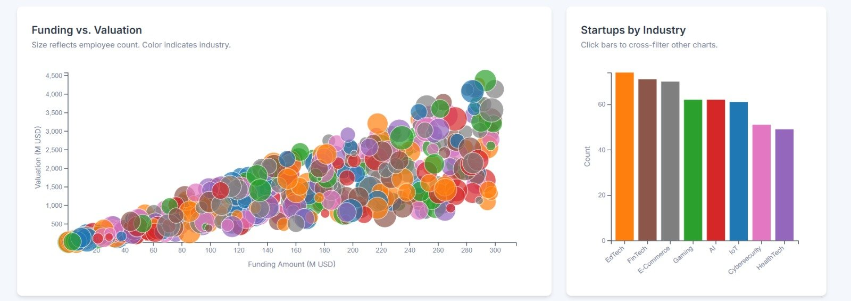
Figure 2: Bubble Scatter Plot (Funding vs. Valuation) and Industry Bar Chart with Cross-Filtering
Funding vs. Valuation (Bubble Scatter Plot)
Objective: Identify correlation between capital raised and company valuation.
Encoding Channel | Variable | Rationale
X-axis position | Funding Amount (M USD) | Continuous financial input variable
Y-axis position | Valuation (M USD) | Market perception of company value
Bubble size | Number of Employees | Encodes organizational scale
Color | Industry | Categorical differentiation across sectors

Startups by Industry (Vertical Bar Chart)
Objective: Compare startup counts across industries and act as a global cross-filter control. Clicking any bar filters all other charts to that industry. Color uses D3's Category10 scale for categorical distinction.

4.2 Revenue vs. Employees & Temporal Trends
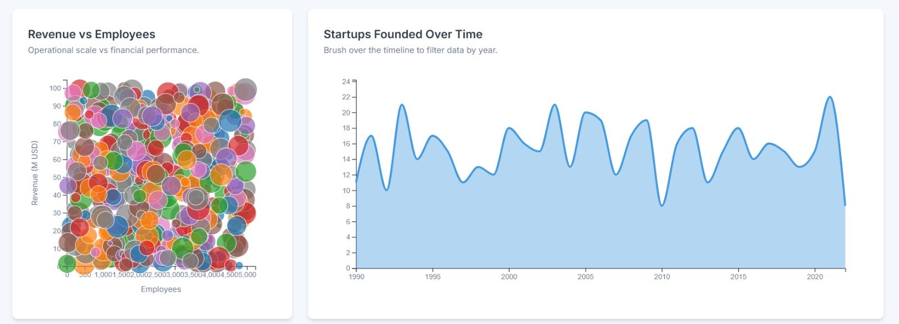
Figure 3: Revenue vs. Employees Scatter Plot and Startups Founded Over Time (Area Chart with Brush)
Revenue vs. Employees (Scatter Plot)
Objective: Analyze the relationship between workforce size and financial output. High revenue with fewer employees indicates high operational efficiency — a valuable outlier detection metric.

Startups Founded Over Time (Area Chart + D3 Brush)
Objective: Visualize temporal trends in startup creation and enable time-based filtering. Users can drag a brush horizontally over the chart to select any year range, which dynamically filters all other visualizations. The area fill uses semi-transparent blue for visual prominence.

4.3 Exit Status, Regional Distribution & Funding Rounds
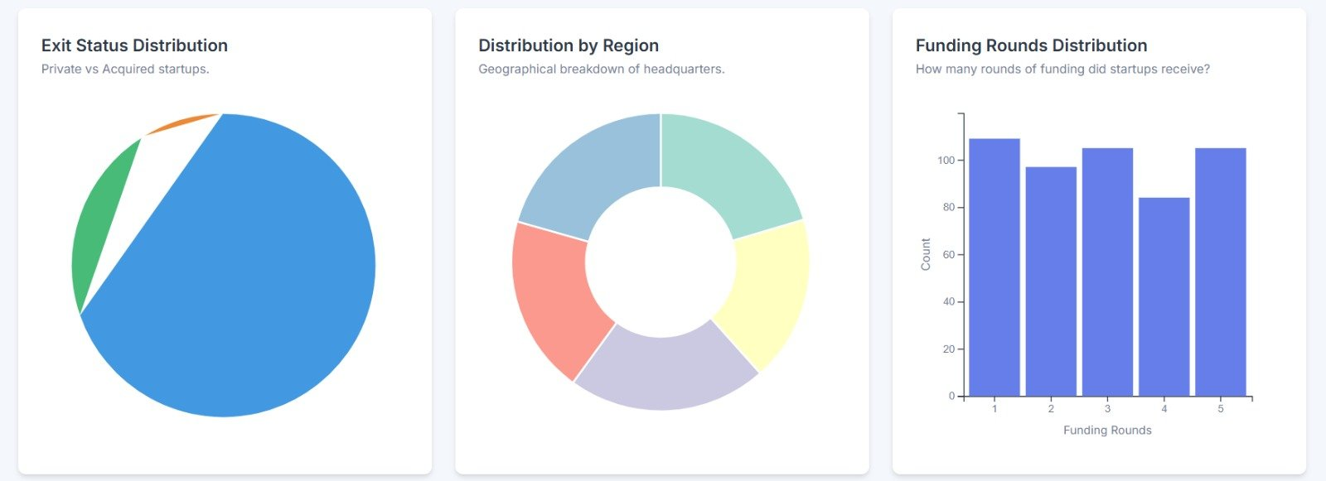
Figure 4: Exit Status Pie Chart, Region Donut Chart, and Funding Rounds Histogram
Exit Status Distribution (Pie Chart)
Objective: Show the breakdown of Private vs. Acquired startups. With only 2–3 categories, the pie chart is appropriate — it gives immediate visual perception of proportion without the complexity problem that afflicts pie charts with many slices.

Distribution by Region (Donut Chart)
Objective: Display geographic distribution of startup headquarters. The donut variant provides a center space for annotation and makes arc sizes slightly easier to compare than a full pie.

Funding Rounds Distribution (Histogram)
Objective: Show how many startups received each number of funding rounds (1 through 5). The near-uniform distribution across rounds indicates the dataset is well-balanced. Bars use an indigo-blue palette consistent with the dashboard accent color.

4.4 Profitability by Industry
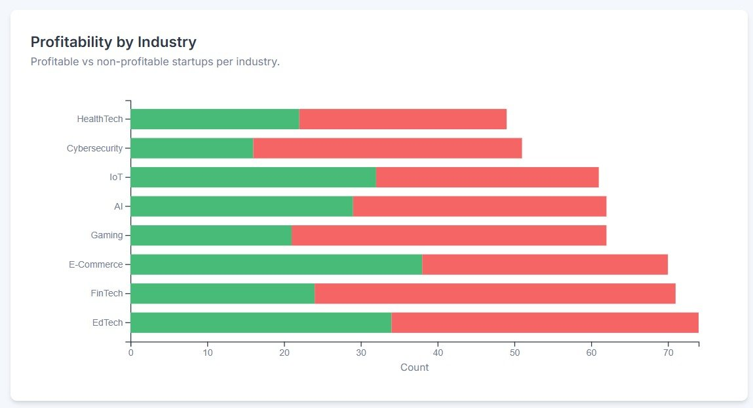
Figure 5: Profitability by Industry — Stacked Horizontal Bar Chart (Green = Profitable, Red = Non-Profitable)
Objective: Compare profitability rates across all 8 industries simultaneously. The stacked horizontal bar chart shows both totals (bar length) and composition (profitable vs. non-profitable segment). Key observations:
- EdTech has the highest total startup count but a relatively low profitability ratio.
- E-Commerce shows the highest profitability proportion among all sectors.
- Cybersecurity has the smallest profitable segment, reflecting the high investment required.
- IoT achieves a balanced split, suggesting operational maturity in the sector.

5. Interactivity & Cross-Filtering

5.1 Interaction Mechanisms
Interaction | Trigger | Effect | Charts Affected
Click | Click bar in Industry chart | Filters all charts to selected industry | All 7 other charts
Brush | Drag horizontally on Line chart | Filters to selected year range | All 7 other charts
Hover / Tooltip | Mouse over any data point | Shows exact values in floating tooltip | All charts individually
Deselect | Click selected bar again | Clears industry filter, restores full data | All charts

5.2 Central Filter Architecture
All charts share a single centralized filter state object in main.js. When any chart triggers a filter event via its callback, the applyFilters() function recalculates the filtered dataset and calls .update(filteredData) on every chart with a D3 750ms transition for smooth animation.

6. Code Structure & Design Patterns

6.1 Folder Hierarchy
Path | Purpose
index.html | Main HTML entry point — semantic structure
assets/css/style.css | All styling: grid layout, colors, responsive breakpoints
assets/js/main.js | Application entry point — orchestrates all charts and filters
assets/js/utils/preprocess.js | Data loading, type conversion, KPI calculation
assets/js/charts/scatterPlot.js | Funding vs. Valuation bubble chart
assets/js/charts/barChart.js | Startups by Industry — click filter source
assets/js/charts/lineChart.js | Temporal trends with D3 brush interaction
assets/js/charts/donutChart.js | Regional distribution donut chart
assets/js/charts/revenueScatter.js | Revenue vs. Employees scatter
assets/js/charts/exitStatusChart.js | Exit status pie chart
assets/js/charts/profitabilityChart.js | Profitability stacked bar chart
assets/js/charts/fundingRoundsChart.js | Funding rounds histogram
assets/datasets/startup_data.csv | Source dataset (500 startup records)

6.2 Design Patterns Applied
- Object-Oriented Chart Classes: Each chart is a class with init(), update(), and destroy() lifecycle methods — enabling reuse and encapsulation.
- Separation of Concerns: Data layer (preprocess.js), view layer (chart files), and logic layer (main.js) are strictly separated.
- Event-Driven Architecture: Charts communicate with the application via callback functions, avoiding tight coupling.
- D3 Data Joins: Key functions ensure D3 updates only changed DOM elements, minimizing re-render cost.

7. Key D3.js Concepts Implemented
D3 Concept | Application in Dashboard
Data Binding & Joins (enter/update/exit) | All charts — ensures smooth transitions when filtered data changes
Linear Scale (scaleLinear) | Scatter plots — maps continuous data to pixel space
Band Scale (scaleBand) | Bar and stacked charts — maps categories to bar positions
Ordinal Color Scale (scaleOrdinal) | Industry colors using d3.schemeCategory10
Time Scale (scaleTime) | X-axis on the temporal area chart
D3 Brush (brushX) | Year range filter on the Startups Founded line chart
D3 Arc / Pie | Exit status pie and regional donut charts
Transitions (.transition().duration(750)) | All chart updates — 750ms smooth animations
Tooltips (mouseover/mouseout) | Floating detail panels on hover across all charts

8. Challenges & Solutions
Challenge | Root Cause | Solution Applied
Donut chart not rendering | Arc transition logic error in attrTween | Rewrote attrTween with proper arc interpolation
Responsive layout broken on mobile | Fixed grid column widths | CSS media queries with minmax() and auto-flow
Cross-filtering across 8 charts | Complex event propagation | Centralized filter state in main.js with callback pattern
Data type mismatches | CSV imports all fields as strings | Row converter in d3.csv() using unary + operator
Tooltip positioned outside viewport | Hard-coded pixel offsets | Relative offset calculation based on cursor position

9. GitHub Pages Deployment

9.1 Deployment Steps
Step | Command / Action
1. Initialize repo | git init
2. Stage all files | git add .
3. Initial commit | git commit -m "Initial commit: Startup Ecosystem Dashboard"
4. Add remote | git remote add origin https://github.com/USERNAME/startup-dashboard.git
5. Push to GitHub | git push -u origin main
6. Enable GitHub Pages | Repository Settings → Pages → Source: main / root → Save
7. Live URL | https://salehayasir.github.io/dvt-lab-final/


9.2 Browser Compatibility
Browser | Min Version | Support
Google Chrome | 90+ | Full Support
Mozilla Firefox | 88+ | Full Support
Apple Safari | 14+ | Full Support
Microsoft Edge | 90+ | Full Support
Internet Explorer 11 | N/A | Not Supported (ES6 syntax)

10. Future Enhancements

10.1 Feature Additions
- Search & Filter UI: Input field to search startups by name or sector
- Data Export: Download currently filtered dataset as CSV
- Comparison Mode: Toggle between two industry subsets side-by-side
- Time Animation: Play button to animate temporal trends over years

10.2 Technical Improvements
- Data Caching: In-memory filtering to eliminate repeated CSV parsing
- Responsive SVG: Dynamic chart resizing on browser window resize
- Unit Tests: Jest/Mocha coverage for preprocessing and chart logic
- Webpack Bundling: Minified JavaScript for faster load times

11. Learning Outcomes
Competency Area | Skills Demonstrated
Data Visualization Fundamentals | Chart type selection, visual encoding (position/size/color), graphical integrity
D3.js Mastery | Data binding/joins, scales, axes, transitions, brush interactions, arc/pie generators
Full-Stack Web Development | Semantic HTML5, CSS Grid, responsive design, ES6+ JavaScript
UI/UX Design | Color theory, layout hierarchy, accessibility, cross-platform responsiveness
Software Engineering | OOP design, separation of concerns, event-driven architecture, Git

12. Conclusion
The Startup Ecosystem Dashboard successfully transforms raw startup data into actionable visual insights through 8 carefully designed, cross-filtered visualizations. The system demonstrates a complete implementation of modern data visualization principles, interactive design patterns, and web development best practices.

The modular, class-based D3.js architecture ensures maintainability and extensibility, while the responsive CSS Grid layout guarantees usability across desktop and mobile devices. Deployment to GitHub Pages makes the project instantly accessible and shareable.

This project fulfills all requirements of CLO 5 — developing a web-based system using interactive visualization techniques and libraries — and serves as a strong portfolio piece demonstrating skills directly relevant to data visualization roles in industry and research.

Field | Value
Project Completion Date | June 18, 2026
Version | 1.0
Status | Production Ready
Hosted URL | https://USERNAME.github.io/startup-dashboard/

